### Michael R. Kealy

Shareholder | Reno

*Michael Kealy offers decades of experience as a litigation and trial attorney, practicing primarily in the areas of commercial litigation, business torts, natural resource and real estate litigation. Mr. Kealy also counsels businesses and individuals in structuring agreements and negotiating solutions to complex disputes.*

### Biography

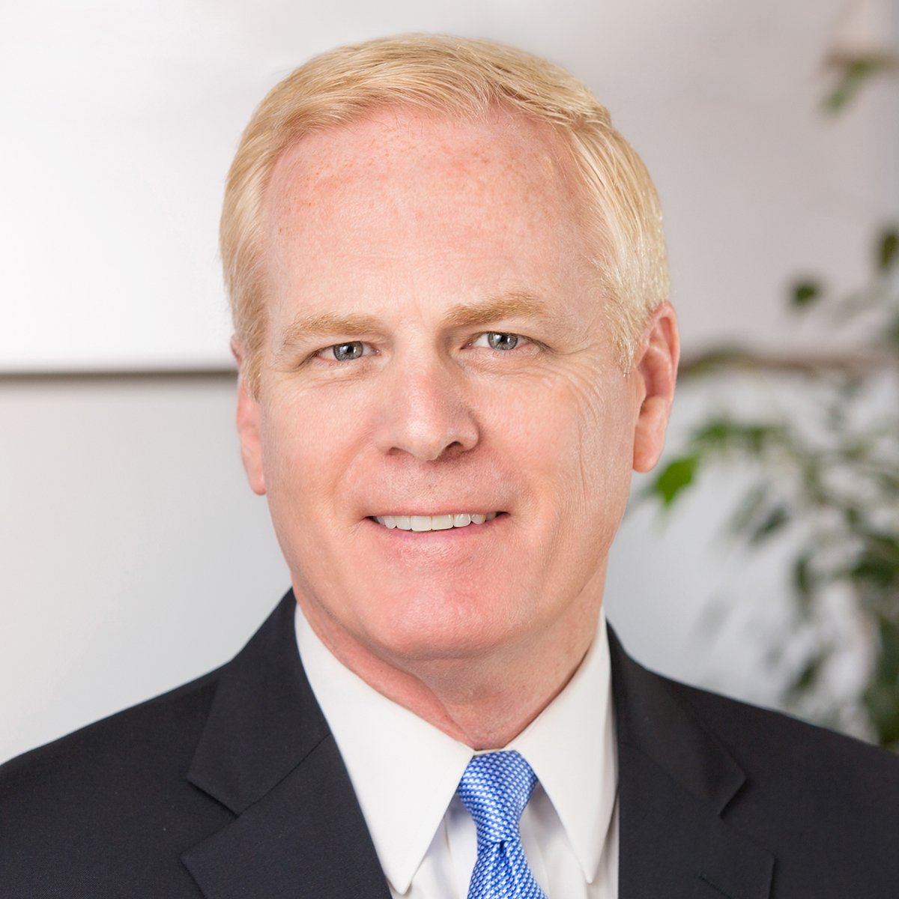

## Contact information

775.323.1601  
[mkealy@parsonsbehle.com](mailto:mkealy@parsonsbehle.com)

# Capabilities

## Appeals

## Business & Commercial Litigation

## Corporate

## Environmental Litigation & Administrative Appeals

## Real Estate

## Real Estate Litigation

## Licensed/Admitted

Nevada

Nebraska

U.S. Court of Appeals, 8th Circuit

U.S. Court of Appeals, 9th Circuit

U.S. Dist. Court, Dist. of Nevada

U.S. Dist. Court, Dist. of Nebraska

U.S. Tax Court

U.S. Supreme Court

Michael Kealy represents clients that include large, national companies; local businesses; employers; political subdivisions and individuals in protecting their real and personal property rights; contractual matters; and business interests. Some examples of Mr. Kealy’s experience include:

Lead counsel in the landmark case of Clean Water Coalition v. The M Resort, LLC, which defined Nevada’s Constitution's limits upon the state legislature's sweeping of funds from political subdivisions. Mr. Kealy successfully protected $62 million of his client’s funds.

Counsel for a large mining company in litigation to protect its water rights in the Humboldt River Basin.

Lead trial counsel in state court on behalf of large rural property owners in successfully protecting easement rights, including an award of attorney fees and an order of contempt against the opposing parties, resulting in their confinement in jail.

Co-trial counsel for a commercial parking and security company owner against other owners over control of the company. Obtained a successful judgment in favor of the client in addition to an award of attorney fees in excess of $500,000 and sanctions against the opponents in excess of $20,000.

Trial counsel for a British investment fund in pursuing a former employee who embezzled more than €50 million and absconded to Nevada. Obtained a temporary restraining order and permanent injunction that ultimately resolved the case and a companion case in Great Britain.

Representing numerous owners of real property and rural ranch properties in disputes over ownership, easements, water rights, royalties, leases and contracts.

### Experience

### Defended Client and Secured Good Faith Settlement

### Defended client against claims from a company that provides medical provider financing. Although the company obtained a judgment in the case collectively in excess of $5 million, a good faith settlement was secured for the client for the sum of $50,000.

### Defended Claims of Interest Royalty and Reached Beneficial Settlement

### Defended mining company from claims that another company is entitled to an interest royalty. Years later, the claim was refiled, and a beneficial settlement was reached for the clients.

### Water Rights Litigation

### Lead litigation counsel for gold mine impacted by litigation that would negatively impact its water rights.

### Defending a Large Gold Mine Against Royalty Claims

### Representing an international gold mining company's mine against royalty claims by another world-class gold mine.

### Nevada Gold Mines, LLC

### Represented Nevada Gold Mines, LLC as lead counsel against the Pershing County Water Conservation District who contended that priority water rights had been negatively impacted by the State Engineer’s alleged improper actions regarding water appropriations and conjunctive management of water rights in the Humboldt River Basin. After years of litigation, the District agreed to dismiss the case with prejudice.

### Pershing County Water Conservation District v. Nevada State Engineer

### Clean Water Coalition v. The M Resort, State of Nevada

### Successfully nullified a state law as an unconstitutional tax and special law which improperly directed the Clean Water Coalition to pay $62 million of wastewater user fees into the Nevada state general fund. The landmark case defined limits on legislative sweeps of political subdivision funds.

### Clean Water Coalition v. The M Resort, LLC, et al., 127 Nev.___, 255 P.3d 247, 127 Nev. Adv. Op. 24 (May 26, 2011)

### Lead counsel in landmark case decided by the Nevada Supreme Court that prevented the Nevada Legislature and Governor from enforcing an unconstitutional tax enacted to sweep $62 million from the funds of a local governmental agency to the State's general fund. The precedent established by this case prevented more than $650 million in sweeps from local governmental entities and municipalities across Nevada during the 2010 legislative session and defined the State Constitution's limits applicable to taxes, special laws and local laws.

### Accomplishments

#### Professional

#### AV® Preeminent™ rating in Martindale-Hubbell

#### *The Best Lawyers in America* 2008 - present

#### Named *Best Lawyers in America* 2022 "Lawyer of the Year" for Reno Personal Injury Litigation – Defendants

#### Named *Best Lawyers in America* 2015 "Lawyer of the Year" for Reno Litigation - Real Estate

#### Recognized in *Chambers USA*, Litigation

#### *Nevada Business Magazine's* “Legal Elite 2012”

#### Academic

### Creighton University School of Law, J.D., 1983

### University of Nebraska-Omaha, B.S.B.A., 1980

### Associations

#### Professional

#### American Bar Foundation, Fellow

#### American Bar Association, Member (1984 - Present)

#### The Bruce R. Thompson American Inn of Court, President (2013 - 2014)

#### Association of Defense Counsel of Northern Nevada, Past President

#### Major Investor – Economic Development Authority of Western Nevada (EDAWN)

#### (Former Member of EDAWN Board of Trustees)